2.91: a) The final speed of the first part of the fall (free fall) is the same as the initial speed of the second part of the fall (with the Rocketeer supplying the upward acceleration), and assuming the student is a rest both at the top of the tower and at the ground, the distances fallen during the first and second parts of the fall are 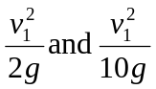, where v₁ is the student's speed when the Rocketeer catches him. The distance fallen in free fall is then five times the distance from the ground when caught, and so the distance above the ground when caught is one-sixth of the height of the tower, or 92.2 m. b) The student falls a distance 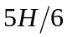 in time 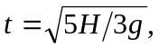 and the Rocketeer falls the same distance in time t–t₀, where t₀=5.00 s (assigning three significant figures to t₀ is more or less arbitrary). Then,

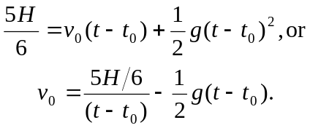
At this point, there is no great advantage in expressing t in terms of H and g algebraically; , from which 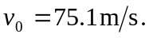

c)
